https://imageacademy.org/

Meta Title:
Cosmetology & Beauty School -Houston, Texas | Image Academy
Meta Description:
Looking to start your career in Cosmetology and Beauty? Image Academy is the leading Cosmetology & Beauty School in Houston.
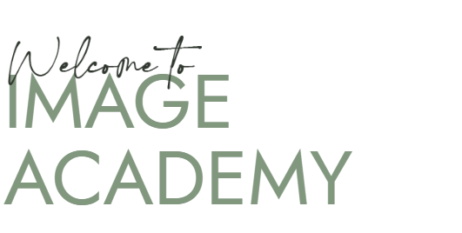

Welcome to Image Academy

Leading Cosmetology & Beauty School in Houston, Texas (h1)

Ready to make beauty your business? Join Image Academy now and find out how your beauty skills make a difference. Our courses will skill you up to become what you want. Contact us today and take your professional life to another level.

CTA: Enroll Now
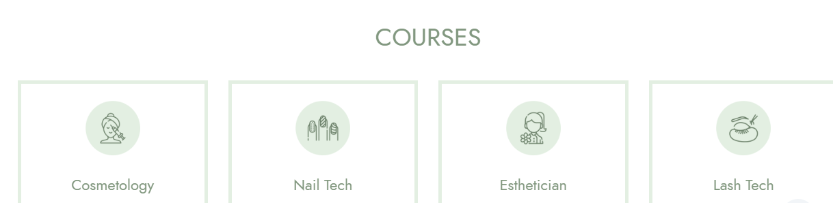

Our Beauty School Courses for Your Bright Future (h2)

Cosmetology | Nail Tech | Esthetician | Lash Tech
Transform your imagination and bring out the best in people in only six months with our cosmetology courses. | Show off your creative side and bring creativity into business by starting our nail tech courses program. | Studying our Esthetician Program helps you unearth the mysteries of skin and beauty trends and developments. | It’s time to turn your passion for lashes into a profession here at Image Academy with our Lash Tech program.



About Image Academy (h2)

Image Academy is a professional Cosmetology & Beauty School - in Houston, Texas that seeks to prepare the next generation of beauty professionals. Our flagship cosmetology school features Cosmetology Programs and skilled faculties that help maintain, develop and enhance the student’s special skills needed in the field.

Among our highly qualified instructors who work in our Beauty Academy, most of them are experienced beauty industry experts. Their passion is to develop future leaders in the field of cosmetology through our Houston Beauty School courses. Check out the bio sections of our inspiring leadership and learn why our school is your best bet to kickstarting your career in our Houston Cosmetology Programs.

Same as above
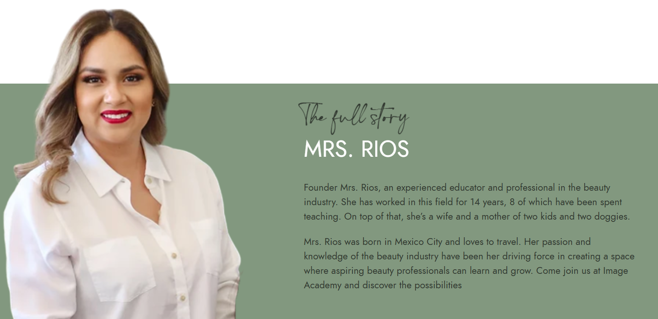

The Full Story MRS. Rios (h2)

Founder Mrs. Rios is a very devoted and experienced teacher as she has a lot of practice in the beauty field. She has been in this industry for 14 years out of which 8 years have been spent in teaching and grooming others. Besides her career, she is a cheerful wife, a mother of two lovely kids and two doggies.

Mrs. Rios was born in Mexico City and has a passion for traveling and beauty. This passion of hers convinced her to start a Beauty Training School in Houston, TX; a place where sweet young beauty enthusiasts would be allowed to learn and grow in the beauty field.
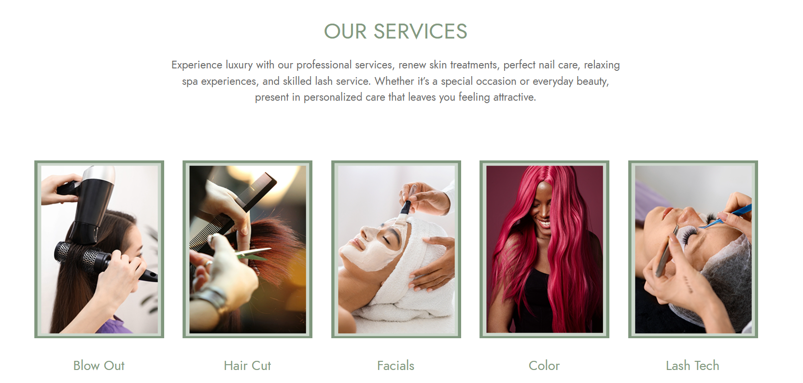

Our Beauty School Services (h2)

Discover the best professional services to elate your beauty at our cosmetology school near me in Houston. Learn more about our beautiful skin solutions, clean beautiful nails, relaxing spa treatments and well-done lashes that enhance overall beauty standards.

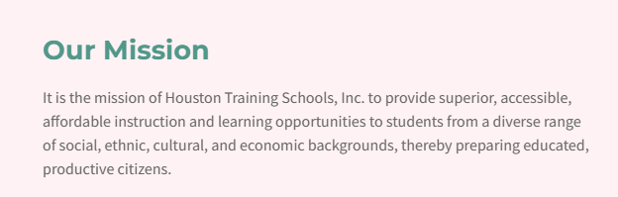

Our Mission (h3)

We are an academy of professional cosmetology experts that aims to provide quality education to all students regardless of their background. It is an honor for us to prepare our students as worthy personnel with high-level competencies that enable them to perform effectively in this dynamic beauty market. The intent of delivering a variety of courses at our cosmetology school in Houston, TX is to produce educated and productive citizens within the community as well as within the industry.

